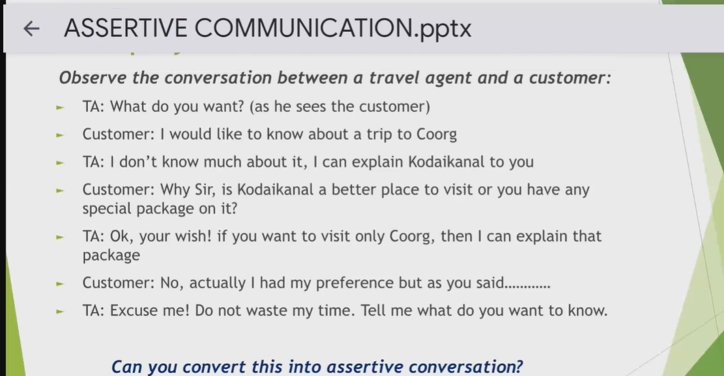

TA : Good morning! How can I assist you today?

Customer: I would like to inquire about a trip to Coorg.

TA: Coorg is a beautiful destination. However, I have more information about Kodaikanal. Would you be interested in hearing about it or do you have specific questions about Coorg?

Customer: Is Kodaikanal a better place to visit or do you have any special packages for it?

TA: Both Coorg and Kodaikanal have their unique charm. If you have a preference for Coorg, I can certainly provide you with details about our packages for that destination.

Customer: Actually, I had my preference for Coorg.

TA: Perfect! I can provide you with all the information you need for your trip to Coorg and what specific details are you looking for?

Customer: going with questions or requests

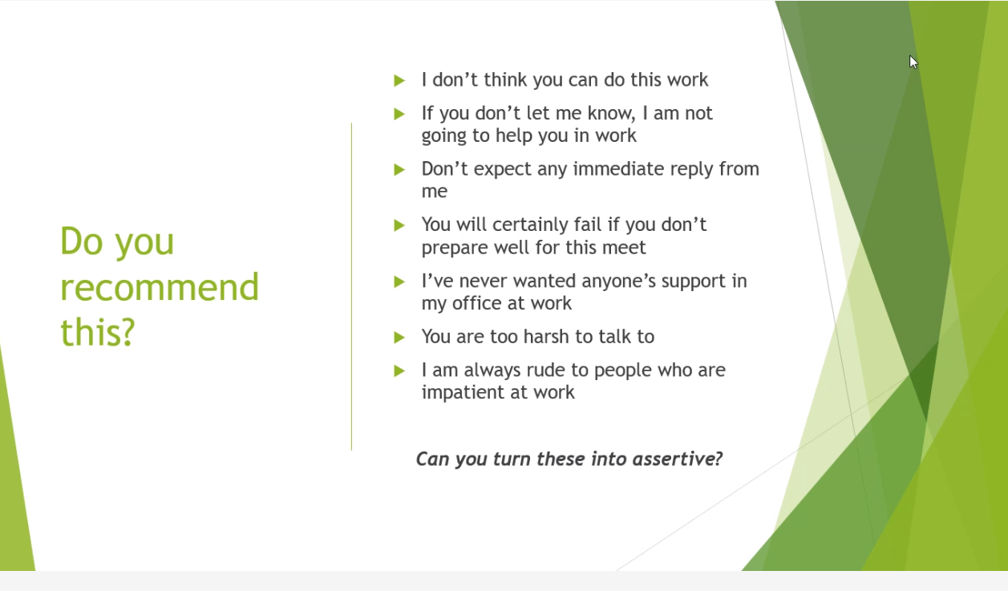

1.

2. Feel free. let me know if you need any help so I can support you

3. I might not be able to reply right away. I'll get back to you as soon as I can.

4. Thorough preparation will really help us succeed in this meeting.

5. I usually work independently, but I value your offer to assist.

6.

7. I find it easier to communicate when we both stay patient.

**Various Elements of Verbal Communication**

**Language Skills:** Including vocabulary, pronunciation, accent, dialect, slang, fluency, sentence building, idioms, proverbs, anecdotal style, and abbreviations used in speaking.

**Voice:** Tone, speed, volume, and clarity of the speaker's voice are essential for effective communication.

**Confidence**: Being confident about the topic being discussed and ensuring the voice is audible to everyone.

**Listening Skills:** Active listening is crucial for understanding and responding appropriately to messages.

**Patience and Attention to Detail**: Important qualities for effective communication.

**Grammar and Vocabulary**: Correct usage of words, spelling, and speaking concisely.

**Persuasion Skills**: Ability to persuade others through verbal communication.

**Clarity and Conciseness**: Clear expression of ideas and speaking succinctly to avoid confusion.

Knowledge about the Topic: Having enough knowledge about the topic being discussed.

**Attitude**: A positive attitude can influence the effectiveness of verbal communication.

**Politeness:** Being polite and respectful in interactions enhances the quality of verbal communication and fosters positive relationships.

=====================================

The various elements of Verbal communication are:

1) Language 14) Subject knowledge

2) Pitch 15) Probing

3) Volume 16) Empathy

4) Pronunciation 17) Active listening

5) Accent

6) Modulation

7) Stress of words

8) Dialect

9) Overall clarity

10) Words

11) Feedback

12) Polite tone

13) Fluency

**Types of communication and practice:**

For building Verbal communication, we need to give enough exercise to our tongue in pronouncing words and sentences regularly.

For Non-verbal communication, we need to practise speaking in front of people like on stage or in virtual meetings clearly without fear and make improvements.

Also practise developing infographics, ppts, graphs, pie charts, bar charts, symbols pictures or any sign-based communication in your presentation.

Keep writing your thoughts clearly in mails, essays, note books, or in any electronic form and proofread the same.

Make use of resources/equipment/infrastructure like training rooms, conference halls, projector, pointers, flip charts, writing boards, markers, stage, podium, notes, notepad or any electronic means of reference material during presentation.

In communication, the transfer of information happens as per the following information:

7% words

38% by vocal elements.

Vocal elements are:

voice, pitch, sound, volume, modulation, tone, pace etc.

any sound that is produced by our mouth is vocal element.

55% - Non-verbal communication which means body language of all sorts.

Non-verbal in this category covers visual and written as well.

45% - (words + vocal is called paralanguage)

So, 7%+38%+55% = 100%

I didn't say that she stole my money.

Tone of the message

1) Modulate enough according to the sentence you are uttering. 2)Communicate non-verbally 3) Establish sync between verbal and non-verbal communication.

Effective, Impressive and Appealing.

Effective means coverage of information, Impressive means making it interesting for others to consume and Appealing means it should be purposeful.

***Verbal Communication also involves Effective listening/Active listening. It means having the ability to follow the steps stated below:***

***Listening - Understanding - Storing - Retrieving – Aligning - Expressing.***

***It is required not only for audio clips but for all the following situations like***

***Meetings, Conversation, Discussion about the project or technology, KT sessions, Training, Telephonic conversations etc.***

***Note-making:***

***Note-making is the most important aspect of storing data while listening  as part of Verbal communication.***

***Paraphrasing:***

***Paraphrasing means listening and expressing using your own words but not allowing any loss of information or at least the theme of the information listened to.***

***Note making and Paraphrasing through Listening-Understanding-Storing-Retrieving-Aligning-Expressing are very important.***

***Sender-Message-Receiver-Feedback - The process of communication.***

***If anyone faces difficulty in expressing building proper sentences though they have proper thoughts in mind; they should write down 5 - 7 lines in a book and read them and practice so that you get a smooth flow. This is an important activity to pick up skills.***